**Assignment 2: Automated S3 Bucket Cleanup Using AWS Lambda and Boto3**

**Objective**: To gain experience with AWS Lambda and Boto3 by creating a Lambda function that will automatically clean up old files in an S3 bucket.

**Task**: Automate the deletion of files older than 30 days in a specific S3 bucket.

***Note: For testing purpose deleted all the files which are older than 1 day in the S3 bucket.***

1. **S3 Setup:**

- Navigate to the S3 dashboard and create a new bucket.

- Upload multiple files to this bucket, ensuring that some files are older than 30 days (you may need to adjust your system's date temporarily for this or use old files).

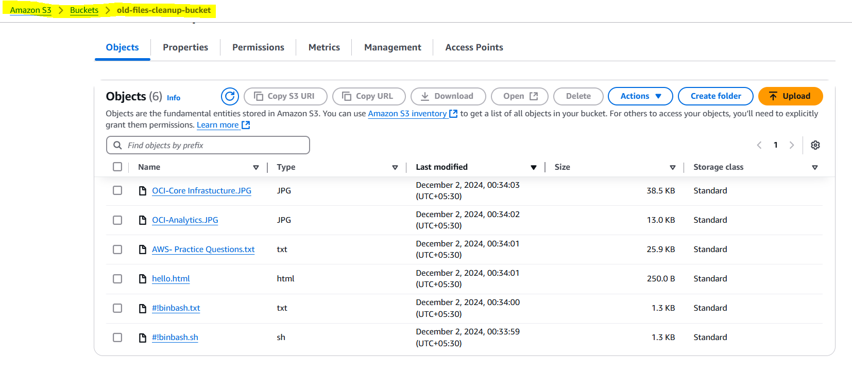

1. **Lambda IAM Role:**

- In the IAM dashboard, create a new role for Lambda.

- Attach the `AmazonS3FullAccess` policy to this role. (Note: For enhanced security in real-world scenarios, use more restrictive permissions.)

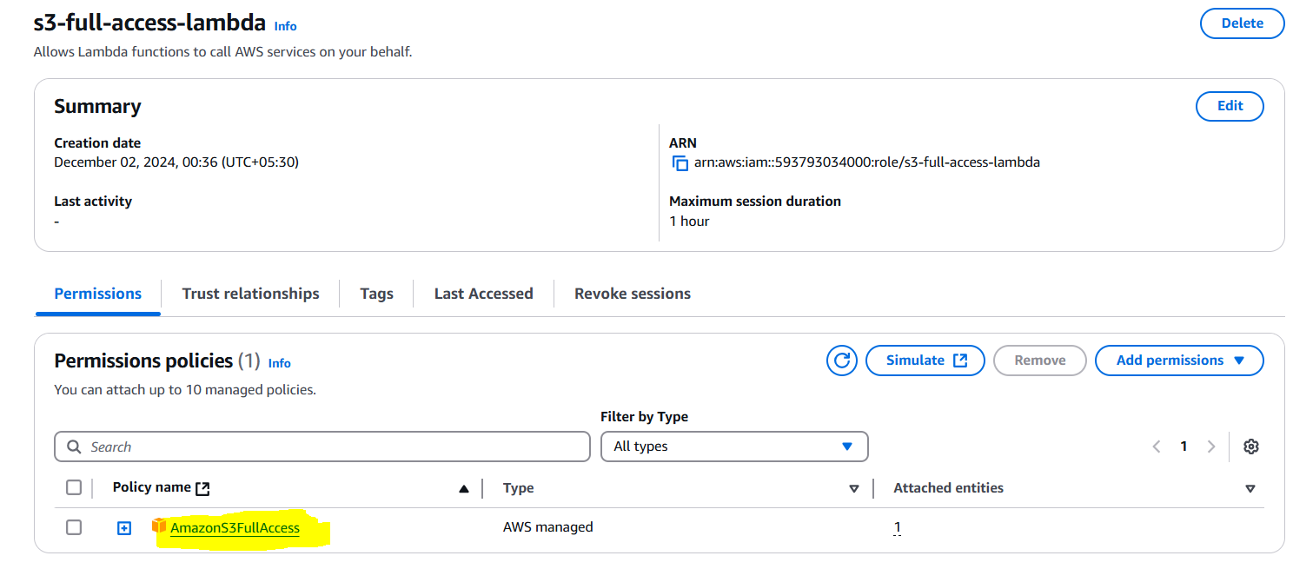

1. **Lambda Function:**

- Navigate to the Lambda dashboard and create a new function.

- Choose Python 3.x as the runtime.

- Assign the IAM role created in the previous step.

- Write the Boto3 Python script to:

1. Initialize a boto3 S3 client.

2. List objects in the specified bucket.

3. Delete objects older than 30 days.

4. Print the names of deleted objects for logging purposes.

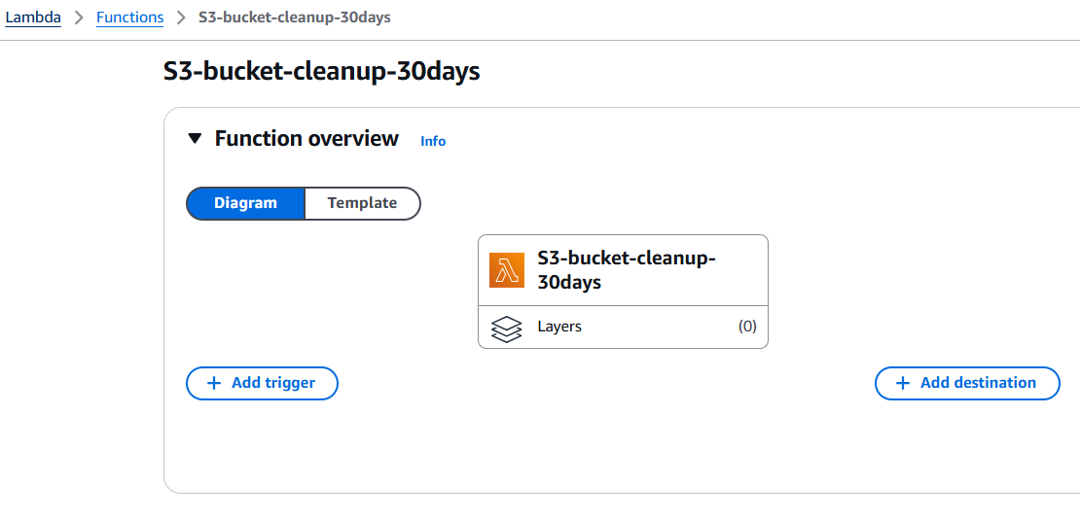

* ***Lambda function run successfully but there is a problem in S3 while uploading any older file in bucket it will take the system date due to which all the files got the same date and as per the code logic file has to be 1 day older. Thus, need to wait for 1 day to perform the task.***

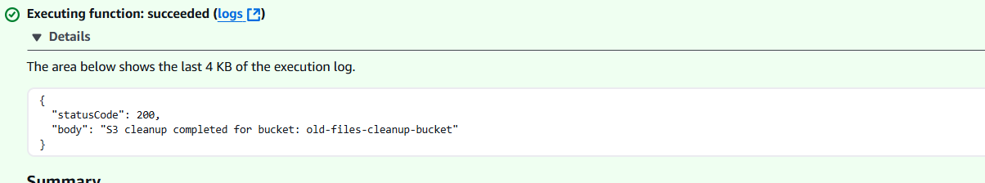

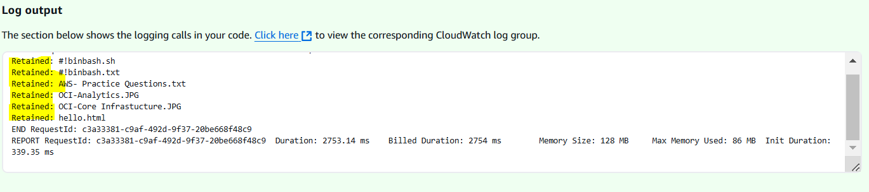

* ***New file uploaded the next day and the S3 bucket takes the system date.***

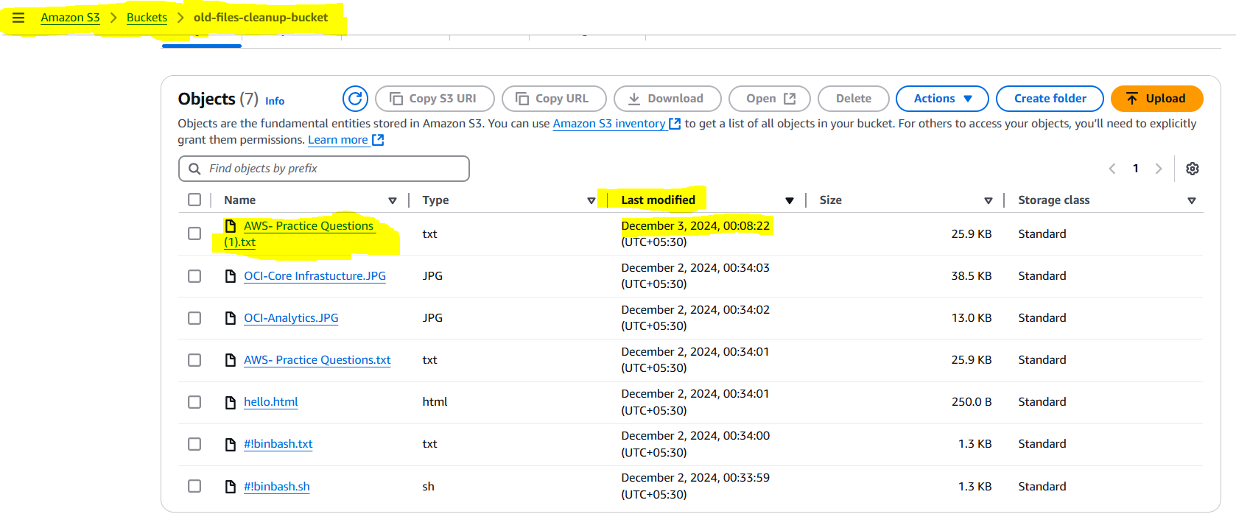

* ***Ran the lambda function again after 1 day and it successfully deleted all the files which were older than 1 day in the bucket.***

